**A report on**



**“**HANDYHIRE: Local Service Provider Hiring App**”**

**Submitted in partial fulfilment for the award of the degree of**

#### BACHELOR OF TECHNOLOGY

**IN**

**COMPUTER SCIENCE & ENGINEERING**

**(SOFTWARE ENGINEERING)**

**Submitted by**

**SACHIN SINGH**

**(20BTRCS170)**

**MANISH YADAV**

**(20BTRSE037)**

**AAYUSHMA THAPA**

**(20BTRSE072)**

**SAMYAK MAHARJAN**

**(20BTRSE076)**

**Under the guidance of Prof. Karthikeyan S**

#### Faculty of Engineering & Technology

**Jain (Deemed-To-Be University) Department of Computer Science and Engineering**

Jain Global Campus, Kanakapura Taluk - 562112 Ramanagara District, Karnataka, India

2022-2023



**Department of Computer Science and Engineering**

Jain Global Campus, Kanakapura Taluk - 562112 Ramanagara District, Karnataka, India

**CERTIFICATE**

This is to certify that the project work titled **“HandyHire”** is carried out by **Sachin Singh (20BTRCS170), Manish Yadav (20BTRSE037), Aayushma Thapa (20BTRSE072)** and **Samyak Maharjan (20BTRSE076)** a Bonafede students of Bachelor of Technology in **Computer Science & Engineering (Software Engineering)** at the Faculty of Engineering & Technology, Jain (Deemed-to-be University), Bangalore in partial fulfilment for the award of degree, Bachelor of Technology in Computer Engineering (Software Engineering) during the Academic year **2022-2023**.

|  |  |  |
| --- | --- | --- |
| **Prof. Karthikeyan S** Guide  Assistant Professor,  Dept. of CSE-SE,  Faculty of Engineering & Technology,  Jain (Deemed-to-be University)  Date: | **Dr. Chandramma R** Program Head,  Dept. of CSE-SE  Faculty of Engineering & Technology,  Jain (Deemed-to-be University)  Date: | **Dr. Geetha G**  Director,  School of Computer Science & Engineering,  Jain (Deemed- to-be University)  Date: |

**Name of the Examiner Signature of Examiner**

1.

2.

# DECLARATION

We**, Sachin Singh (20BTRCS170), Manish Yadav (20BTRSE037), Aayushma Thapa (20BTRSE072),** and **Samyak Maharjan (20BTRSE076)** are students of sixth semester **B. Tech** in **Computer Science & Engineering** (**Software Engineering),** at Faculty of Engineering and Technology, **Jain (Deemed- To-Be) University,** hereby declare that the project centric learning work titled **“HandyHire”** has been carried out by us and submitted in partial fulfilment for the award of degree in **Bachelor of Technology** during the academic year **2022-2023.** Further, the matter presented in the project has not been submitted previously by anybody for the award of any degree or any diploma to any other University, to the best of our knowledge and faith.

Sachin Singh Signature

20BTRCS170

Manish Yadav

20BTRSE037

Aayushma Thapa

20BTRSE072

Samyak Maharjan

20BTRSE072

Place: Bangalore Date:

Signature

Signature

Signature

# ACKNOWLEDGEMENT

*It is a great pleasure for us to acknowledge the assistance and support of a large number of individuals who have been responsible for the successful completion of this project work.*

*First, we take this opportunity to express our sincere gratitude to* ***Faculty of Engineering and Technology, Jain (Deemed-to-be) University,*** *for providing us with a great opportunity to pursue our Bachelor’s Degree in this institution.*

*In particular we would like to thank* ***Dr. Geetha G, Director, School of Computer science and Engineering, Jain (Deemed-to-be University),*** *for his constant encouragement and expert advice.*

*It is a matter of immense pleasure to express our sincere thanks to* ***Dr. Chandramma R, Program Head, Department of Computer Science & Engineering (Software Engineering), Jain (Deemed-to-be University),*** *for providing right academic guidance that made our task possible.*

*We would like to thank our internal guide* ***Mr.* Karthikeyan *S, Department of Computer Science & Engineering (Software Engineering), Jain (Deemed-to-be University),*** *for sparing her valuable time to extend help in every step of our project work, which paved the way for smooth progress and fruitful culmination of the project.*

*We are also grateful to our family and friends who provided us with every requirement throughout the course.*

*We would like to thank one and all who directly or indirectly helped us in completing the Project work successfully.*

***Signature of Students***

1. *Sachin Singh (20BTRCS170)*
2. *Manish Yadav (20BTRSE037)*
3. *Aayushma Thapa (20BTRSE072)*
4. *Samyak Maharjan (20BTRSE076)*

**ABSTRACT**

Our handyman services mobile application aims to provide a convenient and efficient way for users to connect with reliable and skilled local service providers for a range of handyman services. The application will allow users to browse through a list of qualified service providers, view their profiles and reviews, and book appointments with them for services such as plumbing, electrical work, carpentry, and more. Service providers will be able to create profiles on the platform, highlighting their skills and expertise, and providing information about their availability and rates. Users will have the option to pay service providers directly through the application, ensuring a secure and convenient payment process. Our application will provide a streamlined and efficient solution to the problem of finding reliable and qualified local service providers for home repairs and maintenance. By connecting users with a network of trusted and skilled service providers, we hope to make the process of finding and hiring handyman services easy and stress-free for everyone involved.

**TABLE OF CONTENTS**

|  |  |  |
| --- | --- | --- |
| **CERTIFICATE** | 2 | |
| **DECLARATION** | 3 | |
| **ACKNOWLEDGEMENT** | 4 | |
| **ABSTRACT** | 5 | |
| **TABLE OF CONTENT** | 6 | |
| **LIST OF FIGURES** | 7 | |
| **Chapter 1** |  | |
| 1. **INTRODUCTION** | 9 | |
| * 1. Problem Definition | 10 | |
| 1.2. Objectives | 11 | |
| 1.3. Methodology | 12 | |
| 1.4. Hardware and Software Used | 14 | |
| **Chapter 2** |  | |
| 1. **LITERATURE SURVEY** | 15 | |
| 2.1 Existing Application | 19 | |
| 2.2 Limitation of Existing System | 21 | |
| **Chapter 3** |  | |
| 1. **PRPPOSED SYSTEM** |  | |
| 3.1. Proposed System Architecture | 22 | |
| 3.2. Developed System | 24 | |
| **Chapter 4** |  | |
| 1. **CONCLUSION** | 26 | |
| **REFERENCES** | 27 |

# LIST OF FIGURES

|  |  |  |
| --- | --- | --- |
| **Fig. No.** | **Description of Figure** | **Page No.** |
| 3 | System Architecture of HandyHire | 22 |
| 3.1 | Screenshots of mobile application | 24 |
| 3.2 | App integration in Firebase | 25 |

# CHAPTER 1

# INTRODUCTION

Handy Hire is a company that provides repair services for various appliances, including fans. If your fan has stopped working or is making unusual noises, you can contact Handy Hire to get it repaired. The company has a team of skilled technicians who can diagnose and fix the problem quickly and efficiently. When you contact Handy Hire, you will be asked to provide some basic information about the fan, such as the make and model number, as well as a description of the problem. Based on this information, the technician will be able to give you an estimate of the cost and the time it will take to repair the fan. Handy Hire offers a convenient service where they can come to your home or office to repair the fan on-site. Alternatively, you can also drop off the fan at their repair shop. The company uses genuine parts and provides a warranty on their repairs to ensure your satisfaction.

Handy Hire provides a range of repair and home services to help customers with their everyday needs. Here are some examples of the services they offer:

1. Fan repair: Handy Hire can repair all types of fans, including ceiling fans, stand fans, and wall-mounted fans.
2. Appliance repair: The company can also repair other household appliances, such as refrigerators, washing machines, and air conditioners.
3. Plumbing services: Handy Hire offers plumbing services for fixing leaks, installing new pipes, and repairing water heaters.
4. Electrical services: The company has licensed electricians who can help with wiring, circuit breaker issues, and installing new electrical outlets.
5. Carpentry services: Handy Hire offers carpentry services for repairing furniture, installing shelves, and fixing wooden fixtures.
6. Home cleaning services: The company can also provide home cleaning services, including deep cleaning, move-in/out cleaning, and regular cleaning.

Handy Hire is a one-stop-shop for all your repair and home service needs. Their skilled technicians and professionals can handle a variety of tasks to ensure your home is running smoothly. Handy Hire is a home service provider that offers a range of repair and maintenance services to customers. Their goal is to help homeowners and renters keep their homes in top condition, with a focus on convenience and affordability.

The app provides a wide variety of services, including plumbing, electrical, carpentry, cleaning, and appliance repair. Whether you need to fixed the leakage, a ceiling fan repaired, or a deep cleaning of your home, Handy Hire has you covered. One of the key benefits of using Handy Hire is the convenience they offer. Customers can easily book services online or through their mobile app, and the company will send a qualified technician or professional to your home at a time that works for you. Their technicians are skilled and experienced, and they use quality materials and tools to ensure the job is done right the first time. Handy Hire also offers competitive pricing and transparent pricing policies, so you know exactly what you're paying for upfront. The company also provides a satisfaction guarantee, so if you're not happy with the service you receive, they will make it right. Hence, Handy Hire is a trusted and reliable home service provider that can help you keep your home in top condition. With their convenient booking process, skilled technicians, and competitive pricing, they make it easy to take care of your home's repair and maintenance needs. Handy Hire is a reliable and professional service for repairing fans and other appliances. With their expertise and dedication to customer satisfaction, you can trust them to get your fan up and running again in no time.

* 1. **Problem Definition**

Many people encounter difficulties when trying to find reliable and skilled local service providers for home repairs and maintenance. The process of searching for service providers can be time-consuming, and often involves browsing through numerous websites and social media platforms, or relying on word-of-mouth recommendations from friends or family. Furthermore, it can be challenging to verify the quality and reliability of a service provider based on reviews and ratings alone. In addition, many service providers operate on an informal, word-of-mouth basis, which makes it difficult for them to expand their customer base and reach new clients. They may also struggle with maintaining their reputation, as negative reviews or feedback can spread quickly and damage their business. The current system for finding and hiring local vendors is inefficient and frustrating for both users and vendors. There is a need for a platform that connects users with trusted and qualified service providers for a range of handyman services, streamlining the process and making it more efficient for everyone involved.

* 1. **Objectives**

The objective of the proposed project is to overcome the limitations of existing systems by developing a comprehensive and reliable mobile application that provides a wider range of services, ensures better quality assurance, and improves user trust and accessibility. The specific objectives of the project include:

1. Developing a platform that covers a broader range of service categories to meet the diverse needs of users.
2. Incorporating mechanisms to ensure the quality of services provided by the service providers, such as background checks and user feedback.
3. Expanding the coverage of the platform to include more geographic regions, making it accessible to more users.
4. Using advanced technologies such as AI-based recommendation systems to help users find the right service provider more easily.
5. Automating processes such as payment processing and service provider verification to improve efficiency and reduce errors.
6. Implementing robust security and privacy measures to enhance user trust and confidence in the platform.

This project aims to create a mobile application that addresses the limitations of existing systems and provides a comprehensive and reliable solution for users seeking to hire local service providers.

* 1. **Methodology**

The methodology for the proposed project of developing a mobile application for hiring local service providers involves several stages.

1. The first stage is the requirement analysis, where the project team gathers and analyzes the specific requirements of the application. This includes identifying the key features, user roles, and functionalities needed for the platform. It also involves understanding the target audience, their preferences, and the geographic scope of the application.
2. Once the requirements are defined, the next stage is the system design. This includes designing the database schema, defining the application architecture, and creating the user interface wireframes. The design phase also involves determining the integration of necessary APIs and third-party services such as location-based services and payment gateways.
3. After the system design is complete, the development phase begins. The development team utilizes Android Studio as the primary development environment and employs the Java or Kotlin programming language to build the mobile application. They implement the user registration and login functionality, service provider registration, service request submission, and other essential features identified during the requirement analysis.
4. During the development phase, the team ensures that proper security measures are implemented, such as encryption of sensitive user data and secure communication protocols. They also focus on optimizing the application's performance and responsiveness to deliver a smooth user experience.
5. Once the development phase is finished, the application undergoes rigorous testing. This includes functional testing to ensure that all features work as intended, usability testing to evaluate the user interface and user experience, and compatibility testing to ensure the app functions correctly on different Android devices and versions.
6. Upon successful testing, the application moves to the deployment stage. The team prepares the necessary release artifacts, including the signed application package (APK) and relevant app store assets. They may also set up backend infrastructure, such as servers and databases, to support the application's functionality.
7. After deployment, the project team monitors the application's performance and collects user feedback to identify areas for improvement. They continue to release updates and bug fixes to enhance the application's stability and address user concerns.
8. Throughout the project, agile development methodologies, such as Scrum or Kanban, can be employed to manage the development process effectively. Regular communication and collaboration among team members are crucial to ensure the project progresses smoothly and meets the defined objectives.
   1. **Hardware and software used**

The proposed project of developing a mobile application for hiring local service providers involves the use of various hardware and software components.

**Hardware**

In hardware, we use Mobile phones. In the proposed project of developing a mobile application for hiring local service providers, mobile devices serve as the primary platform for users to access and interact with the application. Users will install the application on their smartphones or tablets, providing them with a convenient and portable means of accessing the platform's features and functionalities. Mobile devices enable users to search for local service providers, submit service requests, communicate with service providers, and track the progress of service delivery. Users can browse through service categories, view service provider profiles, and make informed decisions based on ratings, reviews, and other relevant information. They can submit service requests by providing details of the required services, preferred timeframes, and any specific instructions.

**Software**

For developing the application HandyHire, Android Studio is used. Android Studio is used as the primary development environment to develop the mobile application for hiring local service providers. It provides a comprehensive set of tools and features specifically designed for Android app development. Once the development is complete, Android Studio facilitates the packaging and distribution of the application as an APK (Android Package) file, which can be installed on Android devices for testing and deployment.

# CHAPTER 2

**LITERATURE SURVEY**

* + - * 1. In recent years, there has been a growing trend towards the use of mobile applications for hiring local service providers for daily work. These apps allow users to find and hire local service providers, such as plumbers, electricians, carpenters, and other skilled workers, quickly and easily.

|  |  |  |  |
| --- | --- | --- | --- |
| **S.N.** | **Title** | **Objective** | **Key Conclusion** |
| 1 | A Location-Based Service for Handyman Order Placement. | The demand of handymen services has increased due to various socioeconomic factors. Existing services are decentralized and unstructured. | This paper has purposed a mobile application for location handyman services within a location to help streamline this process and provide a structured approach for determining location and quality of service to be provided by handymen.[1] |
| 2 | A Mobile application for locating the available handyman services within a locality | Finding handyman services is difficult especially when one considers travel and migration due to the inconsistencies observed in various market scenarios. Another issue is the assumption that smaller businesses are not capable of providing service(s) of high quality. | The purposed method is based on agile development methodology. The purposed systems to be used in this paper are: Short Messaging Services (SMS)and Android.[2] |
| 3 | Smart Home Services using Android | High demand and requirement for handymen but there is a lack of contact point between individual(s)/organization(s) and handymen. | The application will let the customer choose their own staff and will also have knowledge on their tasks.[3] |
| 4 | Pata Services: a mobile application for professional home maintenance services | Lack of regulation in housing and maintenance due to the lack of qualified handymen leading to unqualified handyman to do these tasks. | Develop a mobile application to identify and hire qualified and registered service providers. The system interface allows users to describe any new case(s). The system then searches the library, retrieves all similar cases, and ranks them according to the similarity index. Once the issues have been resolved, the service provider is rated.[4] |
| 5 | Application for booking handyma-n services using WEBBOOK and Google event calendar technolo-gy | There is no easy solution to the ordering process for handyman services that matches the expertise and demand required. Therefore, we need a system in this case software to overcome these problems, there is an idea to build an Android-based application | The technology used is webhook as an automatic notification before the work schedule, and also google event calendar is used for the scheduling process, a recommendation system to give a handyman recommendation using a collaborative filtering method with the slope one algorithm, the applications are built with an object-oriented approach.[5] |
| 6 | Mobile apps for local services: An exploration of user preferences. | This paper analyzes user preferences for mobile applications that connect them with local service providers, including factors such as trust, reliability, user interface design, and payment security. | The mobile applications will connect local service providers and individual by including all the factors such as trust, reliability, user interface design and other securities like payment security. [6] |
| 7 | TaskRabbit: The design of a reputation system for a mobile marketplace | This paper discusses the design of TaskRabbit's reputation system, which plays a crucial role in building trust between users and service providers. | Design of TaskRabbit’s system will play an important role in building trust between users and service providers which is very much important. [7] |
| 8 | Evaluating the trustworthiness of online service providers: An empirical study. | This paper evaluates user perceptions of trustworthiness of online service providers. | Evaluation of user perceptions of trustworthiness of online service providers which is an important factor in the success of mobile applications that is connect with users and also with local service providers. [8] |
| 9 | Mobile apps for home services: A review of key features and functionalities | This paper provides a comprehensive review of key features and functionalities of mobile applications that connect users with local service providers for home services, including customer reviews, scheduling, and payment systems. | Provide with the good review of key features and some functions of mobile app that connect users with local service providers for home services, including customer review, scheduling and payment systems. [9] |
| 10 | Mobile marketplace platforms:A review of the literature | This paper provides a review of the literature on mobile marketplace platforms, including factors such as user trust, user experience design, and marketing strategies. | Provide a review of literature on mobile marketplace platforms, including factors such as user trust, user experience design, and marketing strategies. [10] |
| 11 | The impact of social influence on trust in online platforms:A survey of the TaskRabbit marketplace. | This paper examines the impact of social influence on trust in the TaskRabbit marketplace and how it affects user behavior and decision-making. | Examine the impact of social influence on trust in the TaskRabbit marketplace and how it affects user behavior and decision-making. [11] |
| 12 | The impact of platform reputation on trust in mobile service marketplaces. | This paper explores the impact of platform reputation on user trust in mobile service marketplaces, highlighting the importance of developing a strong brand reputation for your application. | Describe the impact of platform reputation on user trust in mobile service marketplaces, highlighting the importance of developing a strong brand reputation for your application. [12] |
| 13 | A comprehensive evaluation of usability factors affecting the user experience of mobile apps | This paper provides a comprehensive evaluation of usability factors that affect the user experience of mobile applications, including navigation, visual design, and feedback mechanisms. | Provides a comprehensive evaluation of usability factors that affect the user experience of mobile applications, including navigation, visual design, and feedback mechanisms.[13] |
| 14 | Mobile app adoption by service providers: An empirical study. | This paper examines factors that influence service providers' adoption of mobile applications, including ease of use, perceived usefulness, and compatibility with existing tools and processes. | Examines factors that influence service providers' adoption of mobile applications, including ease of use, perceived usefulness, and compatibility with existing tools and processes.[14] |
| 15 | The impact of mobile app user reviews on app downloads and revenue | This paper explores the impact of user reviews on mobile application downloads and revenue, highlighting the importance of managing and responding to customer feedback to improve the user experience and build a strong brand reputation. | Exploration of the impact of user reviews on mobile application downloads and revenue, highlighting the importance of managing and also it will respond to all the customer feedback to improve the user experience and will build a strong brand reputation.[15] |

* 1. **Existing Applications**

The field of hiring local service providers through mobile applications has seen significant development in the past. Several related works have explored similar concepts and provided solutions in this domain. Here are a few examples of related work done in the past:

TaskRabbit: TaskRabbit is a popular platform that allows users to hire local service providers for various tasks. It provides a mobile application where users can post tasks, browse available service providers, and hire them based on their reviews and ratings. TaskRabbit offers a wide range of services, including home repairs, cleaning, moving assistance, and more.

Thumbtack: Thumbtack is another platform that connects users with local service providers. The mobile application allows users to request services, compare quotes, and hire professionals in various fields such as home improvement, event planning, personal training, and more. Thumbtack emphasizes the importance of customer reviews and ratings to help users make informed hiring decisions.

UrbanClap (now known as Urban Company): UrbanClap is a mobile application that enables users to hire local service professionals in India. The platform offers a wide range of services, including home cleaning, beauty services, appliance repair, and fitness training. The mobile app provides a seamless user experience, allowing users to book services, track appointments, and make secure payments.

Handy: Handy is a mobile app that connects users with local home service professionals, primarily focusing on home repairs, cleaning, and maintenance tasks. The platform offers features such as real-time tracking of service providers, upfront pricing, and secure payment options. Handy emphasizes reliability and quality by vetting and screening its service providers.

HomeAdvisor: HomeAdvisor is a mobile app that connects homeowners with local service professionals for home improvement projects. The platform allows users to browse through a directory of service providers, read customer reviews, request quotes, and schedule appointments. HomeAdvisor provides a range of services, including remodeling, landscaping, and plumbing.

These examples represent a fraction of the related work done in the field of hiring local service providers through mobile applications. They highlight the various features, service categories, and user experiences offered by existing platforms in this domain. The proposed project can draw insights and inspiration from these related works while aiming to provide unique features and address any existing limitations in the current solutions.

* 1. **Limitations of existing system**

Most existing systems focus on a limited number of service categories such as plumbing, carpentry, and electrical works. This limits the range of services that users can access through the platform. There is often no mechanism in place to ensure the quality of services provided by the service providers. Users may end up with unsatisfactory work, leading to complaints and negative reviews. Some existing systems are limited to certain geographic regions, which means that users in other areas may not be able to access their services. Some platforms rely solely on user reviews and ratings to help users find the right service provider, which may not always be reliable. Some existing systems still rely on manual processes for tasks such as payment processing and service provider verification, which can be time-consuming and prone to errors.

These limitations highlight the need for more comprehensive and reliable mobile applications that can provide a wider range of services and ensure better quality assurance, while also improving user trust and accessibility.

**CHAPTER 3**

**PROPOSED SYSTEM ARCHITECTURE**

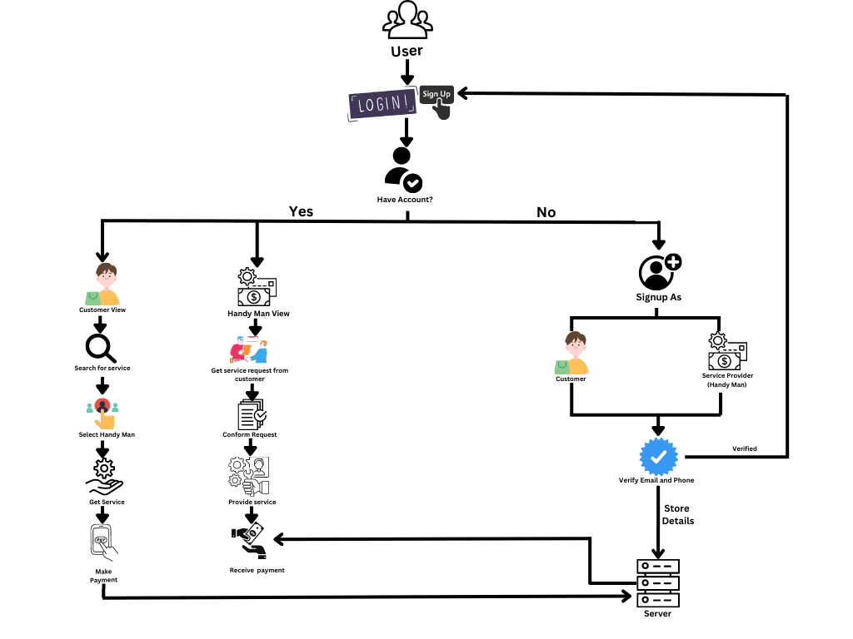

*Fig. 3 - System Architecture of HandyHire*

This mobile application will provide a user-friendly and efficient platform for users to hire local service providers while ensuring quality assurance, user trust, and accessibility.

1. The first step for users is to register on the platform by providing basic personal and contact details. Users can also create a profile and provide additional information such as their location and preferred service categories. Also the service provider can add their details in the
2. Service provider registration: Service providers can also register on the platform by providing their details and service categories. They will also need to undergo a background check and provide any necessary documentation to ensure their credibility.
3. Service request: Users can search for service providers based on location, service category, and ratings. They can then send a request to a particular service provider, providing details of their requirements and expected timeframes.
4. Service provider acceptance: Service providers can review the service request and accept it if they are available and willing to provide the requested services.
5. Service delivery: Service providers will then provide the requested services at the specified location and time, and users can monitor the progress of the service delivery on the platform.
6. Payment: After the service is completed, users can make payments on the platform using secure payment gateways. The platform will deduct a service fee from the payment, and the remaining amount will be transferred to the service provider's account.
7. User feedback and ratings: After the service is completed, users can provide feedback and ratings on the service provider's performance. The feedback will be visible on the service provider's profile, allowing other users to make informed decisions.
8. Dispute resolution: In case of any disputes or complaints, the platform will provide a mechanism for users and service providers to resolve the issues through mediation or arbitration.
   1. **Proposed system**

 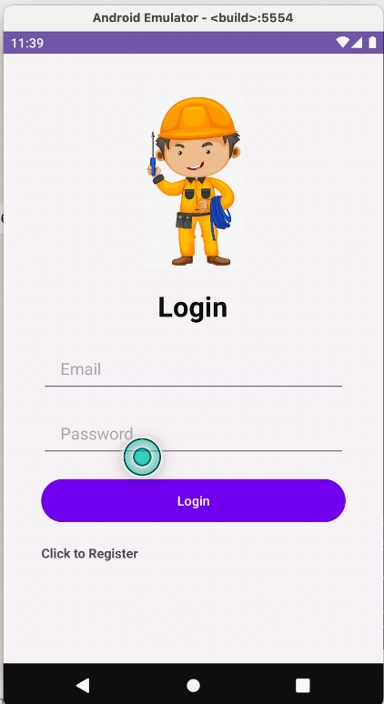

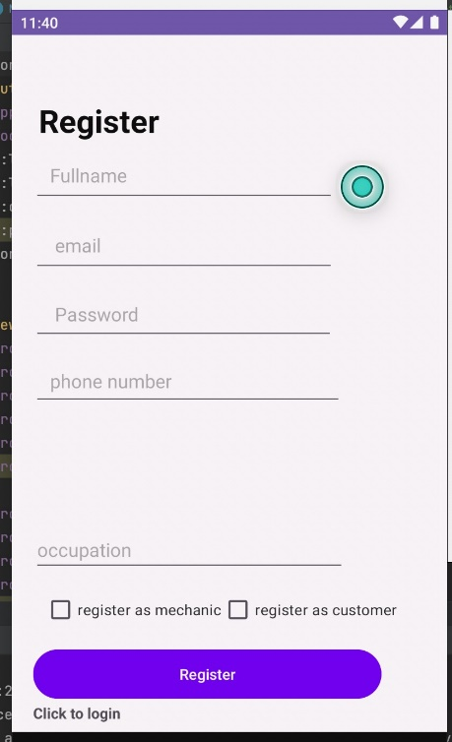 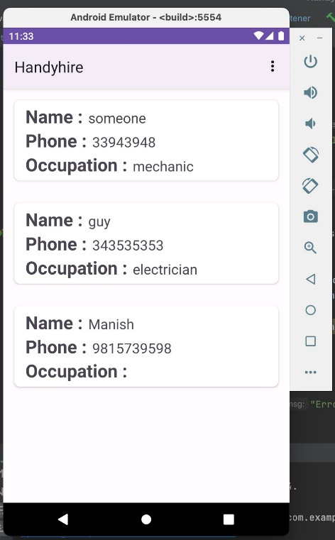

*Fig. 3.1 - Screenshots of mobile application*

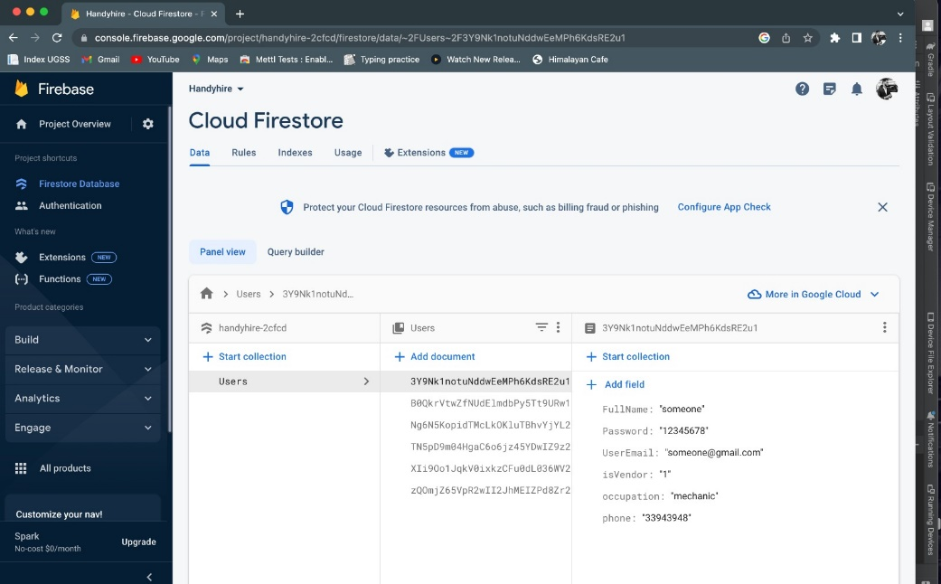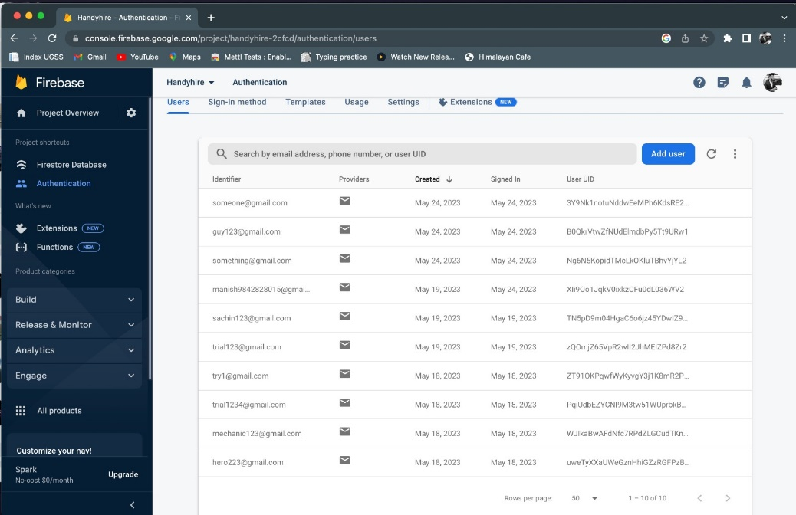

*Fig. 3.1 App integration in Firebase*

This mobile application (HandyHire) will provide a user-friendly and efficient platform for users to hire local service providers, ensuring quality assurance, user trust, and accessibility. The first step for users is to register on the platform by providing basic personal and contact details. They can also create a profile and add additional information such as their location and preferred service categories. Similarly, service providers can register on the platform by providing their details and service categories. They will undergo a background check and submit necessary documentation to ensure their credibility.

Once registered, users can search for service providers based on location, service category, and ratings. They can send a service request to a specific provider, providing details of their requirements and expected timeframes. Service providers can review the request and accept it if they are available and willing to provide the requested services.

After acceptance, service providers will deliver the requested services at the specified location and time. Users can monitor the progress of the service delivery through the platform. Once the service is completed, users can make payments securely on the platform using integrated payment gateways. A service fee will be deducted, and the remaining amount will be transferred to the service provider's account.

To maintain transparency and assist future users, users can provide feedback and ratings on the service provider's performance. This feedback will be visible on the service provider's profile, helping other users make informed decisions.

In the event of any disputes or complaints, the platform will offer a mechanism for users and service providers to resolve issues through mediation or arbitration. This ensures fair resolution and customer satisfaction.

Overall, the mobile application streamlines the process of hiring local service providers by providing a seamless user experience, facilitating secure payments, promoting transparency through feedback and ratings, and offering a dispute resolution system.

**CHAPTER 4**

**CONCLUSION**

In conclusion, the development of a mobile application for hiring local service providers holds immense potential to revolutionize the way individuals connect with and hire professionals for their daily needs. By leveraging the convenience and accessibility of mobile devices, users can easily search, evaluate, and engage with local service providers. The proposed project aims to address the limitations of existing systems, such as limited-service availability, trust and reliability issues, inconsistent service quality, pricing transparency concerns, and customization limitations. By providing a robust and user-friendly platform, the project seeks to empower users to make informed decisions, streamline the hiring process, and enhance overall satisfaction. Ultimately, the successful implementation of this project has the potential to significantly improve the efficiency, convenience, and effectiveness of hiring local service providers.

**REFERENCES**

Shibwabo, Bernard & Gikundi, Denis. (2017). A Location-Based Service for Handyman Order Placement. Journal of Systems Integration. 8. 10.20470/jsi.v8i4.309.

Gikundi, Denis. “A Mobile application for locating the available handyman services within a locality.” (2017).

Smart home services using android mr. T. Kataiah, p.g. Chandana, shaik harshadshameemulla, g. Vaishnav, batta naresh, gali bhavya deepika (2022)

Mwende, J. M. (2018). Pata Services: a mobile application for professional home maintenance services. https://su-plus.strathmore.edu/items/7785532d-bcb1-4130 98fa-f8239a19b1b2

Nafis, R. M., & Setiawan, E. B. (Year). Application for Booking Handyman Services Using Webhook and Google Event Calendar Technology. Unpublished manuscript, Universitas Komputer Indonesia, Bandung, Jawa Barat, Indonesia.

Wu, J., & Sun, L. (2018). Mobile apps for local services: An exploration of user preferences. Journal of Service Theory and Practice, 28(3), 290-307.

Goldman, J., Lotspiech, J., & Weimann, P. (2017). TaskRabbit: The design of a reputation system for a mobile marketplace. In Proceedings of the 2017 CHI Conference on Human Factors in Computing Systems (pp. 2769-2779).

Yan, L., & Han, J. (2018). Evaluating the trustworthiness of online service providers: An empirical study. Computers in Human Behavior, 85, 232-242.

Lee, S., Lee, J. Y., & Kim, J. (2019). Mobile apps for home services: A review of key features and functionalities. International Journal of Industrial Ergonomics, 71, 143-151.

Li, Y., & Khazanchi, M. (2018). Mobile marketplace platforms: A review of the literature. Communications of the Association for Information Systems, 42(1), 187-208.

Goldman, J., Lotspiech, J., & Weimann, P. (2018). The impact of social influence on trust in online platforms: A survey of the TaskRabbit marketplace. ACM Transactions on Computer-Human Interaction (TOCHI), 25(1), 1-36.

Goldman, J., Lotspiech, J., & Weimann, P. (2018). The impact of social influence on trust in online platforms: A survey of the TaskRabbit marketplace. ACM Transactions on Computer-Human Interaction (TOCHI), 25(1), 1-36.

Deng, A., & Li, P. (2019). A comprehensive evaluation of usability factors affecting the user experience of mobile apps. International Journal of Human-Computer Interaction, 35(7), 567-579.

Oh, R., & Kwon, Y. (2018). Mobile app adoption by service providers: An empirical study. Journal of Business Research, 89, 280-286.

Zhu, R., Zhang, W., & Wang, Y. (2019). The impact of mobile app user reviews on app downloads and revenue. Journal of Marketing Analytics, 7(1), 1-16.